STARTUP INCUBATOR CUM CENTRE OF EXCELLENCE
located at PT. CLS. Government College, Sector 14, Karnal
Startup Incubator Cum Centre of Excellence Powered By

Department of Higher Education, Haryana Start-up Accelerator Chamber of Commerce

What is SACC?
Start-up Incubator cum Centre of Excellence is a platform for students to work on their Entrepreneurial skills. The goal behind Startup Incubator is to develop Self- Confidence, Entrepreneurial Skills and to build capacity among participants and encourage students to become job creators rather being job seekers.
SACC MISSION:
- To promote like-minded entrepreneurial ventures.
- To build a knowledge base for Start-Up’s.
- Identify and support New Business Enterprises.
- Develop Business Ideation at School/College Level.
- Encourage Innovative Start-up's, develop and encourage Women entrepreneurs

Yes, we help students to become entrepreneurs and create employment.

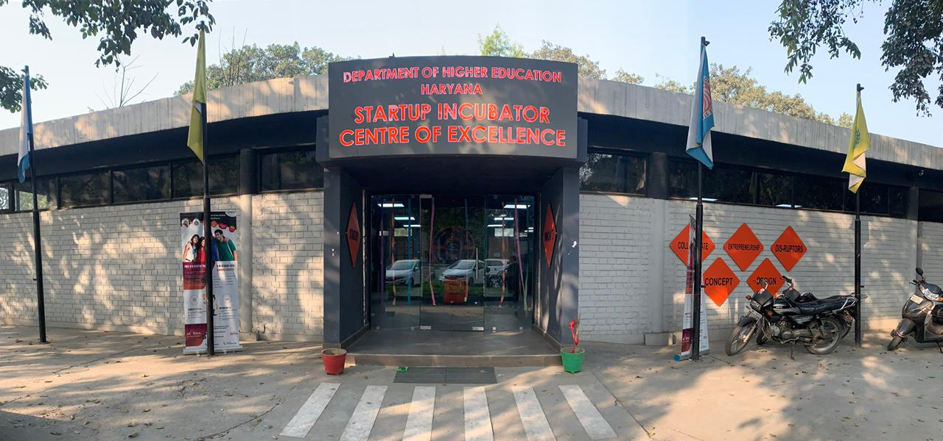

TABLE OF CONTENTS
S. NO. | TITLE | PAGE NO.
1 | EVENTS CONDUCTED TILL MARCH, 2021  - Workshops  - My Story Sessions  - Incubated Start-up Teams  - Mentorship Sessions  - Awareness Sessions  - Boot Camp Sessions  - Outreach Sessions  - Webinars  - Haryana Acceleration Programme | 3-15
2 | FOOTFALL GENERATION | 16
3 | REGISTERED STARTUP TEAMS | 17
4 | REVENUE OF REGISTERED STARTU TEAMS | 18
5 | SECTORIAL DIVERSIFIED | 19

EVENTS CONDUCTED TILL FEBRUARY, 2021
WORKSHOPS
S NO. | WORKSHOPS | DATE | HOST NAME | AUDIENCE
1 | MEHANDI WORKSHOP 1 (PT. CLS GOVT. COLLEGE, SECTOR 14, KARNAL) | 16-10-2019 | MS. MUSKAN | 100
2 | MEHANDI WORKSHOP 2 (GOVT. COLLEGE WOMEN, KARNAL) | 16-10-2019 | MS. MUSKAN | 80
3 | DEEPAWALI EXHIBITION 1 (PT. CLS GOVT. COLLEGE, SECTOR 14, KARNAL) | 23-10-2019 | MR. SUNANT | 150
4 | DEEPAWALI EXHIBITION 2 (GOVT. COLLEGE WOMEN, KARNAL) | 23-10-2019 | MR. SUNANT | 200
5 | STARTUP MEET | 01-01-2020 | MR. SUNANT | 50
6 | MEHANDI WORKSHOP 1 | 03-11-2020 | MR. SUNANT | 40
7 | WINTER STARTUP SCHOOL | 04 JAN TO 17 JAN, 2021 | MR. SUNANT | 30
8 | ONLINE MARKETING WORKSHOP | 08 FEB TO 13 FEB, 2021 | MR. SUNANT | 40

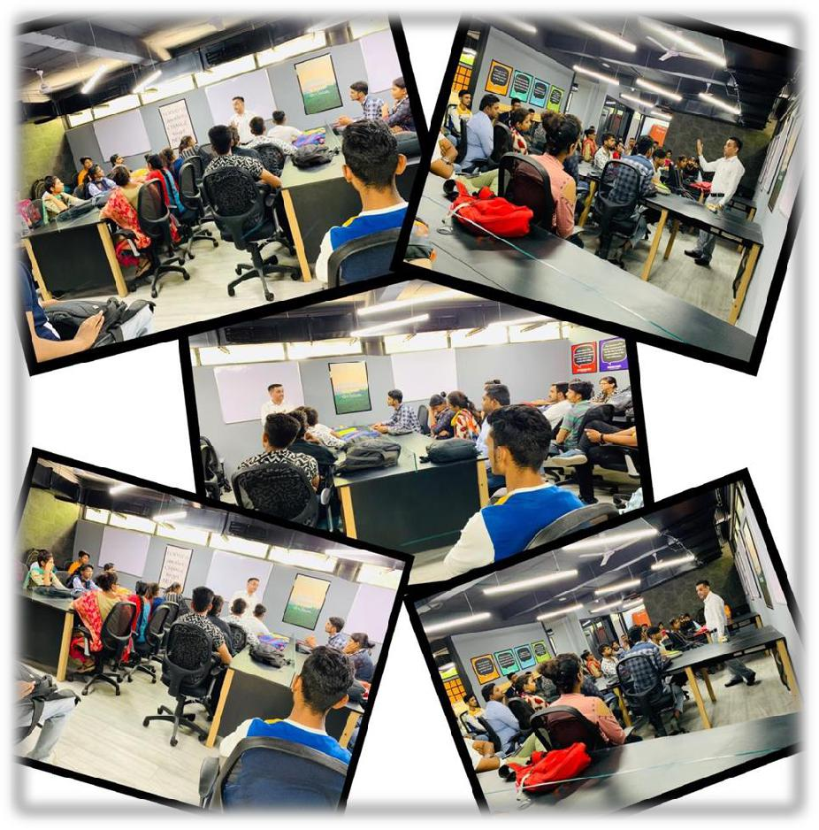

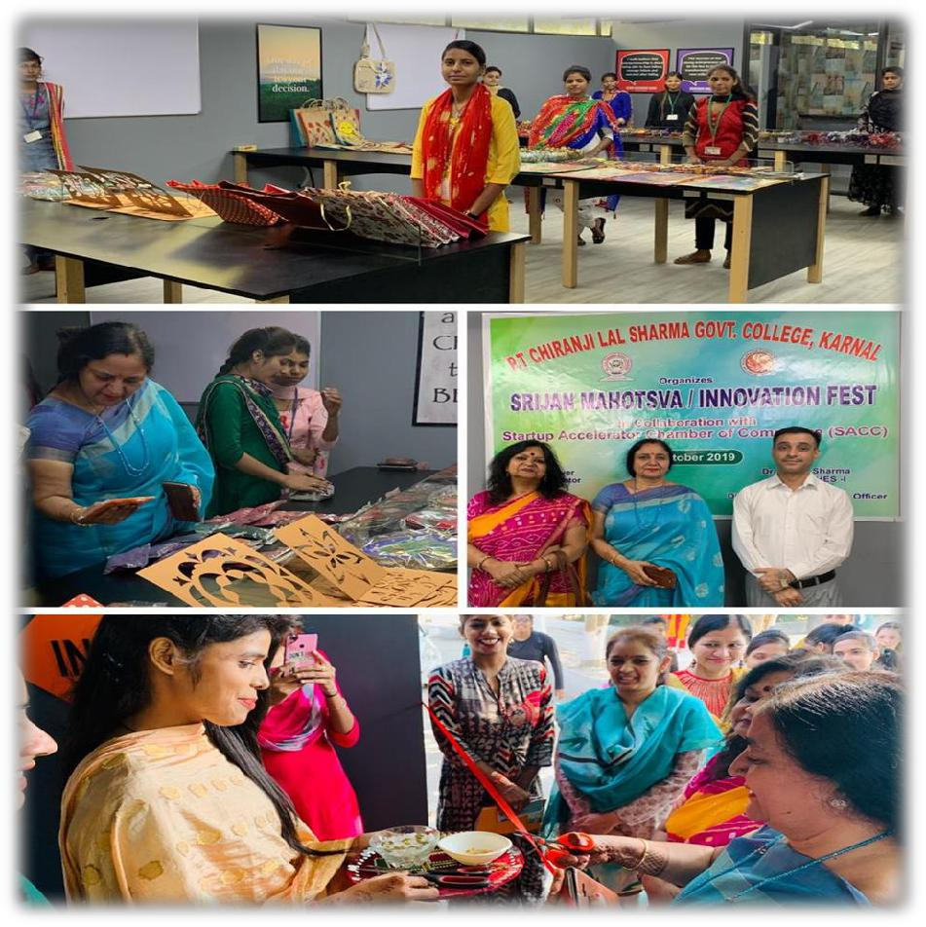

MY STORY SESSION
S NO. | MY STORY SESSIONS | DATE | PARTICIPANTS
1 | WOMEN EMPIRE | 01-01-2020 | NEHA
2 | BUILD IT BETTER | 01-01-2020 | HIMANSHI
3 | AROUND SERVICES | 01-01-2020 | KAMAL& SAHIL
4 | HERCRAFTS | 01-01-2020 | DIKSHA & ANKITA
5 | HAPPY HANDS | 01-01-2020 | DIMPAL
6 | BOOK4U | 01-01-2020 | SAHIL
7 | BOOK WORLD | 01-01-2020 | SHIVANI & VIDUSHI
8 | CRAFT HUB | 01-01-2020 | DIMPI
9 | DIGICELL | 01-01-2020 | MAYANK
10 | NAVU ART & CRAFT | 01-01-2020 | NAVNEET
11 | PERCEPTION 2.0. | 01-01-2020 | VANDANA
12 | ARTYCRAFTY | 01-01-2020 | DIKSHA
13 | THE LEARNING POINT | 01-01-2020 | SONIA
14 | SHOP TOWNS | 01-01-2020 | SACHIN
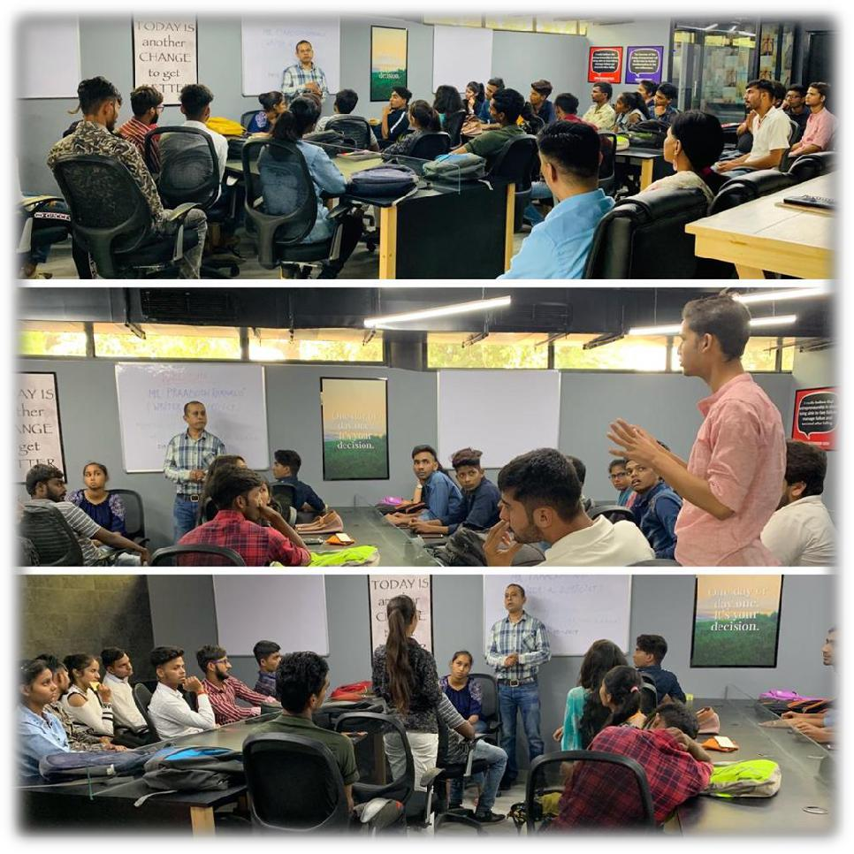

INCUBATED STARTUP TEAMS

S NO. | NAME | STARTUP IDEA
1 | TAMANNA | ART & CRAFT
2 | JYOTI | ART & CRAFT
3 | MEENAKSHI | FASHION DESIGNING
4 | SURAJ | ONLINE EDUCATION PORTAL
5 | MAHIMA | ONLINE
6 | REKHA | ART & CRAFT
7 | NAVNEETA | MEHANDI
8 | GARIMA | ART & CRAFT
9 | SAPNA | CATERING

MENTORSHIP SESSIONS
S NO. | MENTORSHIP SESSION | DATE | SPEAKER NAME | AUDIENCE
1 | MENTORSHIP SESSION (IT & DIGITAL MARKETING) | 01-01-2020 | MR. MANMOHAN SINGH | 40
2 | MENTORSHIP SESSION (ENTREPRENEURSHIP SKILLS) | 02-01-2020 | MR. AMITABH SINGH | 60
3 | MENTORSHIP SESSION (REGISTRATION OF COMPANIES) | 03-01-2020 | MR. SUNANT GROVER | 50
4 | MENTORSHIP SESSION (MAINTAINING PROJECT REPORT) | 06-01-2020 | MR. KAPIL MADAAN | 20
5 | MENTORSHIP SESSION (MSME SCHEMES) | 07-01-2020 | MR. DK TYAGI | 22
6 | MENTORSHIP SESSION (BANKING & FINANCIAL SCHEMES) | 08-01-2020 | MR. NK SIKKA | 20
7 | MENTORSHIP SESSION (INTELLECTUAL PROPERTY DEVELOPMENT) | 09-01-2020 | MR. AMARDEV SINGH | 20
8 | MENTORSHIP SESSION (E-MARKET PLACE) | 10-01-2020 | MRS. MEENU | 22
9 | MENTORSHIP SESSION (INDUSTRIAL DEVELOPMENT) | 13-01-2020 | MR. ASHISH SEYYAL | 22
10 | MENTORSHIP SESSION (EXPORT MANAGEMENT) | 13-01-2020 | MR. SANJAY | 22
11 | MENTORSHIP SESSION (DIGITAL MARKETING) | 14-01-2020 | MR. SUNANT GROVER | 22
12 | MENTORSHIP SESSION (AGRIPRENEURSHIP) | 14-02-2020 | DR. RS CHAUHAN | 60
13 | MENTORSHIP SESSION (DISCUSSION ON STARTUP PROBLEMS) | 19-10-2019 | MR PRADOSH | 40
14 | MENTORSHIP SESSION (DIGITAL MARKETING) | 06-03-2020 | MS. ANJALI | 30
15 | MENTORSHIP SESSION (ONLINE MARKETING) | 06-01-2021 | MS. ANJALI | 23
16 | MENTORSHIP SESSION (TIME MANAGEMENT) | 07-01-2021 | MR. KULDEEP KAUSHIK | 25
17 | MENTORSHIP SESSION (BUSINESS MODEL) | 12-01-2021 | MR. RAHUL | 30
18 | MENTORSHIP SESSION (TAX AND REBATES) | 12-01-2021 | MR. MOHIT | 29
19 | MENTORSHIP SESSION (LEADERSHIP SKILLS) | 09-01-2021 | MS. KAVERI | 30
20 | MENTORSHIP SESSION (KNOW YOUR COMPETITION) | 10-01-2021 | MR. SAMEER | 28
21 | MENTORSHIP SESSION (DIGITAL MARKETING) | 09-02-2021 | MR. GAURAV | 30
22 | MENTORSHIP SESSION (AMAZON AND FLIPKART) | 10-02-2021 | MR. GULSHAN | 29

AWARENESS SESSIONS
S NO. | TITLE | DATE | SPEAKER NAME | AUDIENCE
 | AWARENESS SESSION
1 | AWARENESS SESSION (IDEA OF ENTREPRENEURSHIP) | 26-09-2019 | MR. SUNANT GROVER | 50
2 | AWARENESS SESSION (FACILITIES PROVIDED AT STARTUP INCUBATR) | 28-09-2019 | MR. SUNANT GROVER | 30
3 | AWARENESS SESSION (CONCEPT OF STARTUP INCUBATOR) | 30-09-2019 | MR. SUNANT GROVER | 50
4 | AWARENESS SESSION (IDEA SHARING) | 01-10-2019 | MR. SUNANT GROVER | 100
5 | AWARENESS SESSION (QUERY SOLVING) | 03-10-2019 | MR. SUNANT GROVER | 15
6 | AWARENESS SESSION (SUPPORT SYSTEM) | 04-10-2019 | MR. SUNANT GROVER | 65
7 | AWARENESS SESSION (IDEA DISCUSSION) | 05-10-2019 | MR. SUNANT GROVER | 70
8 | AWARENESS SESSION (IDEA DISCUSSION) | 07-10-2019 | MR. SUNANT GROVER | 30
9 | AWARENESS SESSION (DISCUSSION OF ORGANISING EXHIBITION) | 09-10-2019 | MR. SUNANT GROVER | 50
10 | AWARENESS SESSION (MOTIVATIONAL LECTURE) | 10-10-2019 | MR. SUNANT GROVER | 100
11 | AWARENESS SESSION (IDEA DISCUSSION) | 11-10-2019 | MR. SUNANT GROVER | 80
12 | AWARENESS SESSION (PLANNING OF EXHIBITION) | 12-10-2019 | MR. SUNANT GROVER | 60
13 | AWARENESS SESSION (ORGANISING EXHIBITION) | 14-10-2019 | MR. SUNANT GROVER | 70
14 | AWARENESS SESSION (FACILITIES) | 15-10-2019 | MR. SUNANT GROVER | 40
15 | AWARENESS SESSION (IDEA OF ENTREPRENEURSHIP) | 04-12-2019 | MR. SUNANT GROVER | 40
16 | AWARENESS SESSION (SUPPORT AND FACILITIES) | 17-12-2019 | MR. SUNANT GROVER | 20
17 | AWARENESS SESSION (IDEA OF ENTREPRENEURSHIP) | 06-01-2020 | MR. SUNANT GROVER | 75
18 | AWARENESS SESSION (SUPPORT AND FACILITIES) | 10-01-2020 | MR. SUNANT GROVER | 40
19 | AWARENESS SESSION (SUPPORT AND FACILITIES) | 11-01-2020 | MR. SUNANT GROVER | 30
20 | AWARENESS SESSION (SUPPORT AND FACILITIES) | 17-01-2020 | MR. SUNANT GROVER | 75
21 | AWARENESS SESSION (IDEA SHARING) | 20-01-2020 | MR. SUNANT GROVER | 30
22 | AWARENESS SESSION (CONCEPT OF STARTUP INCUBATOR) | 21-01-2020 | MR. SUNANT GROVER | 40
23 | AWARENESS SESSION (CONCEPT OF STARTUP INCUBATOR) | 23-01-2020 | MR. SUNANT GROVER | 60
24 | AWARENESS SESSION (SUPPORT AND FACILITIES) | 25-01-2020 | MR. SUNANT GROVER | 30
25 | AWARENESS SESSION (IDEA SHARING SESSION) | 28-01-2020 | MR. SUNANT GROVER | 10
26 | AWARENESS SESSION (CONCEPT OF ENTREPRENEURSHIP) | 04-02-2020 | MR. SUNANT GROVER | 20
27 | AWARENESS SESSION (CONCEPT OF ENTREPRENEURSHIP) | 06-02-2020 | MR. SUNANT GROVER | 25
28 | AWARENESS SESSION (FINANCIAL SUPPORT) | 07-02-2020 | MR. SUNANT GROVER | 50
29 | AWARENESS SESSION (CONCEPT OF ENTREPRENEURSHIP) | 14-02-2020 | MR. SUNANT GROVER | 25
30 | AWARENESS SESSION (SUPPORT AND FACILITIES) | 14-02-2020 | MR. SUNANT GROVER | 60
31 | AWARENESS SESSION (CONCEPT OF ENTREPRENEURSHIP) | 18-02-2020 | MR. SUNANT GROVER | 40
32 | AWARENESS SESSION (SUPPORT AND FACILITIES) | 20-02-2020 | MR. SUNANT GROVER | 40
33 | AWARENESS SESSION (CONCEPT OF ENTREPRENEURSHIP) | 22-02-2020 | MR. SUNANT GROVER | 60
34 | AWARENESS SESSION (PROTOTYPE) | 07-03-2020 | MR. SUNANT GROVER | 50
35 | AWARENESS SESSION (IDEA DISCUSSION) | 11-03-2020 | MR. SUNANT GROVER | 40
36 | AWARENESS SESSION (HOW TO RECOGNISE SKILL SET) | 24-11-2020 | MR. SUNANT GROVER | 5
37 | AWARENESS SESSION (CONCEPT OF ENTREPRENEURSHIP) | 25-11-2020 | MR. SUNANT GROVER | 10
38 | AWARENESS SESSION (CONCEPT OF ENTREPRENEURSHIP) | 11-12-2020 | MR. SUNANT GROVER | 20
39 | AWARENESS SESSION (CONCEPT OF ENTREPRENEURSHIP) | 15-12-2020 | MR. SUNANT GROVER | 10
40 | AWARENESS SESSION (CONCEPT OF ENTREPRENEURSHIP) | 21-12-2020 | MR. SUNANT GROVER | 25
41 | AWARENESS SESSION (CONCEPT OF ENTREPRENEURSHIP) | 24-12-2020 | MR. SUNANT GROVER | 15
42 | AWARENESS SESSION (CONCEPT OF ENTREPRENEURSHIP) | 28-12-2020 | MR. SUNANT GROVER | 30
43 | AWARENESS SESSION (CONCEPT OF ENTREPRENEURSHIP) | 04-01-2021 | MR. SUNANT GROVER | 40
44 | AWARENESS SESSION (CONCEPT OF ENTREPRENEURSHIP) | 05-01-2021 | MR. SUNANT GROVER | 27
45 | AWARENESS SESSION (CONCEPT OF ENTREPRENEURSHIP) | 06-01-2021 | MR. SUNANT GROVER | 10
46 | AWARENESS SESSION (CONCEPT OF ENTREPRENEURSHIP) | 07-01-2021 | MR. SUNANT GROVER | 30
47 | AWARENESS SESSION (CONCEPT OF ENTREPRENEURSHIP) | 08-01-2021 | MR. SUNANT GROVER | 35
48 | AWARENESS SESSION (CONCEPT OF ENTREPRENEURSHIP) | 19-01-2021 | MR. SUNANT GROVER | 15
49 | AWARENESS SESSION (CONCEPT OF ENTREPRENEURSHIP) | 25-01-2021 | MR. SUNANT GROVER | 25
50 | AWARENESS SESSION (CONCEPT OF ENTREPRENEURSHIP) | 02-02-2021 | MR. SUNANT GROVER | 30
51 | AWARENESS SESSION (CONCEPT OF ENTREPRENEURSHIP) | 02-03-2021 | MR. SUNANT GROVER | 15
52 | AWARENESS SESSION (CONCEPT OF ENTREPRENEURSHIP) | 02-04-2021 | MR. SUNANT GROVER | 25
53 | AWARENESS SESSION (CONCEPT OF ENTREPRENEURSHIP) | 02-08-2021 | MR. SUNANT GROVER | 35
54 | AWARENESS SESSION (CONCEPT OF ENTREPRENEURSHIP) | 02-09-2021 | MR. SUNANT GROVER | 40
55 | AWARENESS SESSION (CONCEPT OF ENTREPRENEURSHIP) | 02-12-2021 | MR. SUNANT GROVER | 15
56 | AWARENESS SESSION (CONCEPT OF ENTREPRENEURSHIP) | 02-19-2021 | MR. SUNANT GROVER | 45
57 | AWARENESS SESSION (CONCEPT OF ENTREPRENEURSHIP) | 03-16-2021 | MR. SUNANT GROVER | 25
58 | AWARENESS SESSION (CONCEPT OF ENTREPRENEURSHIP) | 03-24-2021 | MR. SUNANT GROVER | 15

BOOTCAMP SESSIONS
S NO. | BOOTCAMP SESSIONS | DATE | SPEAKER | AUDIENCE
1 | BOOTCAMP SESSION ON INFORMATION ABOUT STARTUP INCUBATOR | 30-12-2019 | MR. SUNANT GROVER | 110
2 | BOOTCAMP SESSION ON ABOUT STARTUP INCUBATOR | 05-02-2020 | MR. SUNANT GROVER | 500
3 | BOOTCAMP SESSION ON ABOUT STARTUP INCUBATOR | 28-02-2020 | MR. SUNANT GROVER | 180
4 | BOOTCAMP SESSION ON ABOUT STARTUP INCUBATOR | 03-03-2020 | MR. SUNANT GROVER | 120
5 | BOOTCAMP SESSION ON ABOUT STARTUP INCUBATOR | 06-03-2020 | MR. SUNANT GROVER | 125
6 | BOOTCAMP IN GOVERNMENT COLLEGE, GHARAUNDA | 18-02-2020 | MR. SUNANT GROVER | 60
7 | BOOTCAMP IN GOVERNMENT COLLEGE FOR WOMEN, KARNAL | 26-02-2021 | MR. SUNANT GROVER | 110
8 | BOOTCAMP IN NCC CAMP, GOVERNMENT PG COLLEGE, SECTOR 14, KARNAL | 05-02-2021 | MR. SUNANT GROVER | 250
9 | BOOTCAMP IN NCC CAMP, GOVERNMENT PG COLLEGE, SECTOR 14, KARNAL | 09-02-2020 | MR. SUNANT GROVER | 325

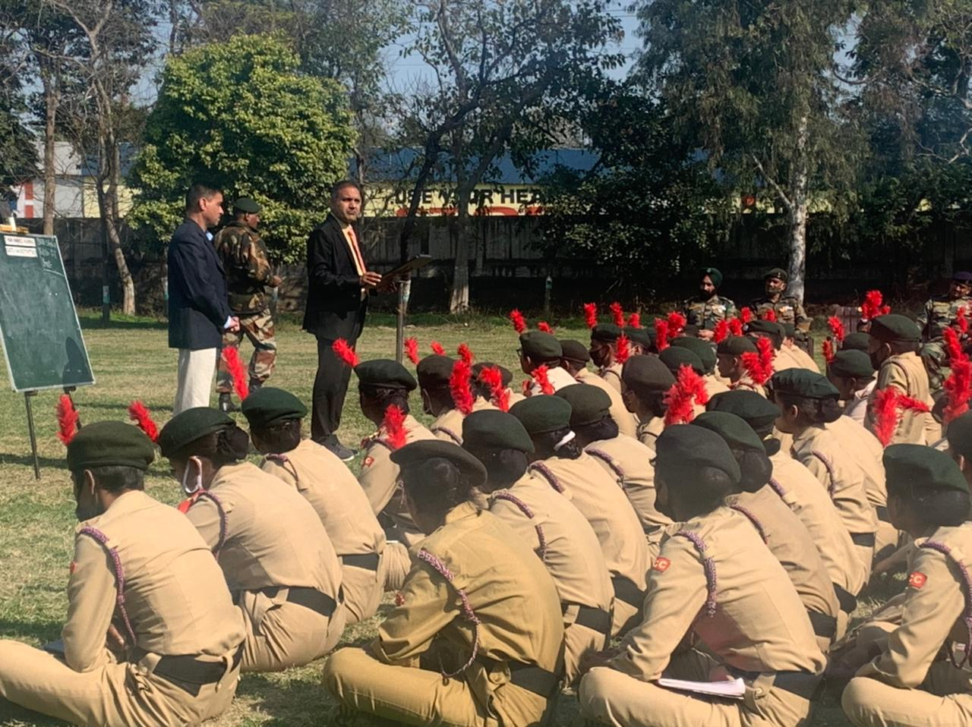

OUTREACH SESSIONS
S NO. | OUTREACH SESSIONS | DATE | SPEAKER NAME | AUDIENCE
1 | OUTREACH SESSION (CONCEPT OF STARTUP INCUBATOR) | 24-09-2019 | MR. SUNANT GROVER | 50
2 | OUTREACH SESSION (CONCEPT OF STARTUP INCUBATOR) | 27-09-2019 | MR. SUNANT GROVER | 100
3 | OUTREACH SESSION (CONCEPT OF STARTUP INCUBATOR) | 18-10-2019 | MR. SUNANT GROVER | 135
4 | OUTREACH SESSION (CONCEPT OF STARTUP INCUBATOR) | 30-12-2019 | MR. SUNANT GROVER | 100
5 | OUTREACH SESSION (CONCEPT OF STARTUP INCUBATOR) | 18-01-2020 | MR. SUNANT GROVER | 40
6 | OUTREACH SESSION (CONCEPT OF STARTUP INCUBATOR) | 27-01-2020 | MR. SUNANT GROVER | 60
7 | OUTREACH SESSION (CONCEPT OF STARTUP INCUBATOR) | 03-02-2020 | MR. SUNANT GROVER | 70
8 | OUTREACH SESSION (CONCEPT OF STARTUP INCUBATOR) | 05-02-2020 | MR. SUNANT GROVER | 50
9 | OUTREACH SESSION (CONCEPT OF STARTUP INCUBATOR) | 10-02-2020 | MR. SUNANT GROVER | 35
10 | OUTREACH SESSION (CONCEPT OF STARTUP INCUBATOR) | 10-02-2020 | MR. SUNANT GROVER | 40
11 | OUTREACH SESSION (CONCEPT OF STARTUP INCUBATOR) | 11-02-2020 | MR. SUNANT GROVER | 50
12 | OUTREACH SESSION (CONCEPT OF STARTUP INCUBATOR) | 27-02-2020 | MR. SUNANT GROVER | 40
13 | OUTREACH SESSION (CONCEPT OF STARTUP INCUBATOR) | 28-02-2020 | MR. SUNANT GROVER | 150
14 | OUTREACH SESSION (CONCEPT OF STARTUP INCUBATOR) | 29-02-2020 | MR. SUNANT GROVER | 50
15 | OUTREACH SESSION (CONCEPT OF STARTUP INCUBATOR) | 02-03-2020 | MR. SUNANT GROVER | 80
16 | OUTREACH SESSION (CONCEPT OF STARTUP INCUBATOR) | 03-03-2020 | MR. SUNANT GROVER | 280
17 | OUTREACH SESSION (CONCEPT OF STARTUP INCUBATOR) | 04-03-2020 | MR. SUNANT GROVER | 110
18 | OUTREACH SESSION (CONCEPT OF STARTUP INCUBATOR) | 05-03-2020 | MR. SUNANT GROVER | 75
19 | OUTREACH SESSION (CONCEPT OF STARTUP INCUBATOR) | 06-03-2020 | MR. SUNANT GROVER | 125
20 | OUTREACH SESSION (CONCEPT OF STARTUP INCUBATOR) | 06-03-2020 | MR. SUNANT GROVER | 35
21 | OUTREACH SESSION (CONCEPT OF STARTUP INCUBATOR) | 07-01-2021 | MR. SUNANT GROVER | 20
22 | OUTREACH SESSION (CONCEPT OF STARTUP INCUBATOR) | 12-01-2021 | MR. SUNANT GROVER | 30
23 | OUTREACH SESSION (CONCEPT OF STARTUP INCUBATOR) | 13-01-2021 | MR. SUNANT GROVER | 25
24 | OUTREACH SESSION (CONCEPT OF STARTUP INCUBATOR) | 19-01-2021 | MR. SUNANT GROVER | 25
25 | OUTREACH SESSION (CONCEPT OF STARTUP INCUBATOR) | 02-02-2021 | MR. SUNANT GROVER | 50
26 | OUTREACH SESSION (CONCEPT OF STARTUP INCUBATOR) | 03-02-2021 | MR. SUNANT GROVER | 250
27 | OUTREACH SESSION (CONCEPT OF STARTUP INCUBATOR) | 08-02-2021 | MR. SUNANT GROVER | 40
28 | OUTREACH SESSION (CONCEPT OF STARTUP INCUBATOR) | 10-02-2021 | MR. SUNANT GROVER | 60
29 | OUTREACH SESSION (CONCEPT OF STARTUP INCUBATOR) | 11-02-2021 | MR. SUNANT GROVER | 125
27 | OUTREACH SESSION (CONCEPT OF STARTUP INCUBATOR) | 11-02-2021 | MR. SUNANT GROVER | 80
28 | OUTREACH SESSION (CONCEPT OF STARTUP INCUBATOR) | 22-02-2021 | MR. SUNANT GROVER | 110

WEBINARS
S NO. | WEBINAR TITLE | DATE | SPEAKER NAME | AUDIENCE
1 | WEBINAR ON EFFECTIVE BUISNESS SKILLS | 07-04-2020 | MR. SUNANT GROVER | 35
2 | WEBINAR ON HOW TO ADD UNIQUENESS TO YOUR STARTUP | 14-04-2020 | MR. SUNANT GROVER | 30
3 | WEBINAR HOW TO UTILISE YOUR TIME EFFECTIVELY | 21-04-2020 | MR. SUNANT GROVER | 73
4 | WEBINAR ON SUCCESS OF STARTUPS | 28-04-2020 | MR. SUNANT GROVER | 73
5 | WEBINAR ON MY JOURNEY ON TERRAIN OF ONLINE BUISNESS | 05-05-2020 | MR. SACHIN KUMAR | 47
6 | WEBINAR ON INTER STARTUP DISCUSSION | 12-05-2020 | MR. SUNANT GROVER | 53
7 | WEBINAR ON INTER STARTUP DISCUSSION | 19-05-2020 | MR. SUNANT GROVER | 36
8 | WEBINAR ON INTER STARTUP DISCUSSION | 26-05-2020 | MR. SUNANT GROVER | 50
9 | WEBINAR ON HOW TO CREATE STARTUP | 02-06-2020 | MR. SUNANT GROVER | 41
10 | WEBINAR ON FOOD FOR THOUGHT | 09-06-2020 | MR. NITIN | 90
11 | WEBINAR ON FUNDING AND FINANCIAL MANAGEMENT | 16-06-2020 | CA MOHIT KAMBOJ | 25
12 | WEBINAR ON BUISNESS SKILLS | 23-06-2020 | MR. SUNANT GROVER | 12
13 | WEBINAR ON ONLINE LEARINING THE NEW NORMAL | 30-06-2020 | MR. MANMOHAN SINGH | 70
14 | WEBINAR ON HOW PERSISTANCE CAN HELP STARTUPS | 07-07-2020 | MR. RAJ GERA | 75
15 | WEBINAR ON HOW TO RECOGNISE YOUR BLIND SPOTS | 14-07-2020 | MR. SUNANT GROVER | 70
16 | WEBINAR ON STRESS MANAGEMENT | 21-07-2020 | DR. KAVERI | 55
17 | WEBINAR ON EMOTIONAL INTELLIGENCE FOR STARTUPS | 28-07-2020 | MR. HARPAL SINGH | 40
18 | WEBINAR ON ENTREPRENEURIAL JOURNEY OF A STUDENT | 04-08-2020 | MR. MAYANK BANSAL | 23
19 | WEBINAR ON SCHEMES AND POLICIES OF MSME | 11-08-2020 | MR. DK TYAGI | 55
20 | WEBINAR ON ALL ABOUT STARTUP NETWORKING | 18-08-2020 | MR. SUNANT GROVER | 45
21 | WEBINAR ON HOW TO SOLVE PROBLEMS | 25-08-2020 | MR. SUNANT GROVER | 31
22 | WEBINAR ON DECODING THE STARTUP LIFECYCLE | 01-09-2020 | MR. SUNANT GROVER | 25
23 | WEBINAR ON GOAL SETTING AND ACHEIEVING | 08-09-2020 | MR. SUNANT GROVER | 22
24 | WEBINAR ON PERSONAL DEVELOPMENT | 15-09-2020 | MR. SUNANT GROVER | 28
25 | WEBINAR ON STARTUP MINDSET | 22-09-2020 | MR. SUNANT GROVER | 25
26 | WEBINAR ON MINDFULNESS FOR STARTUPS | 29-09-2020 | MR. SUNANT GROVER | 25

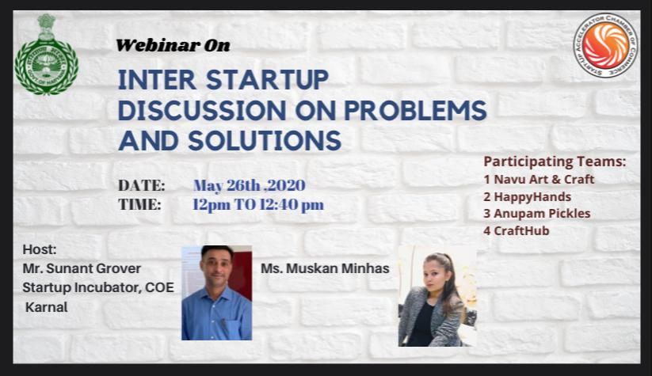

HARYANA ACCELERATOR PROGRAM
S NO. | WEBINAR ON HARYANA ACCELERATOR PROGRAM | AUG-OCT, 2020 | SPEAKER
1 | INTRODUCTIOM, IDEAL SELECTION, IDEA VALIDATION | 04-08-2020 | MR. EKANT AGGARWAL
2 | NETWORKING OF STARTUPS, PROBLEM IDENTIFICATION | 06-08-2020 | MR. SUNANT GROVER
3 | SELECTION OF TARGET MARKET | 11-08-2020 | MR. PK KHURANA
4 | MENTOR SESSION ON HOW TO TARTGET MARKET | 13-08-2020 | MR. SARTAJ LAMBA
5 | TYPE OF LEGAL ENTITIES | 18-08-2020 | MS. ANURADHA CHAWLA
6 | REGISTRATION PROCESS | 20-08-2020 | MS. ANURADHA CHAWLA
7 | FINANCIAL MANAGEMENT | 25-08-2020 | CA HITESH
8 | MILLY SESSION | 27-08-2020 | MR. EKANT AGGARWAL
9 | MENTOR SESSION ON FINANCE | 27-08-2020 | MR. GAGAN UPPAL
10 | IDEANTIFYING COMPETITION | 01-09-2020 | MR. SANJAY SACHDEVA
11 | MILLY SESSION | 03-09-2020 | MS. TANUSHREE CHANDRA
12 | PRODUCT/SERVICE PRICING | 08-09-2020 | MR. JD GHAI
13 | DISCOUNTING AND STRATAGIES | 08-09-2020 | MR. DEEPAK CHOPRA
14 | MENTOR SESSION ON PRICIING | 10-09-2020 | MR. HITESH GULATI
15 | ONLINE/OFFLINE SALES | 15-09-2020 | MR. AMIT DODA
16 | MENTOR SESSION ON SALES | 17-09-2020 | MR. MANINDER TULI
17 | NETWORKING SESSION | 22-09-2020 | MS. MANJULA SULARIA
18 | PITCHING | 24-09-2020 | MR. VINEET KHURANA
19 | CONCLUSION | 24-09-2020 | MR. EKANT AGGARWAL

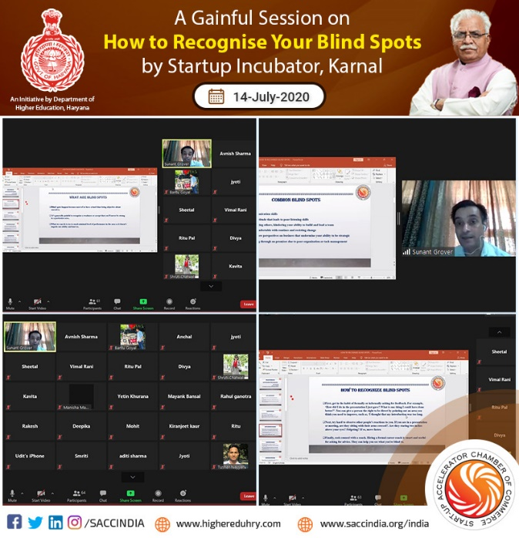
FOOTFALL GENERATION

S NO. | TITLE | NUMBER OF STUDENTS
1 | NUMBER OF STUDENTS SENSITISED THROUGH OUTREACH SESSION | 7856
2 | NUMBER OF STARTUP APPLICATION RECEIVED | 124
3 | NUMBER OF STUDENTS SELECTED FOR INCUBATION | 35
4 | REGISTRED STARTUP TEAMS | 30
5 | INCUBATED STARTUPS | 9

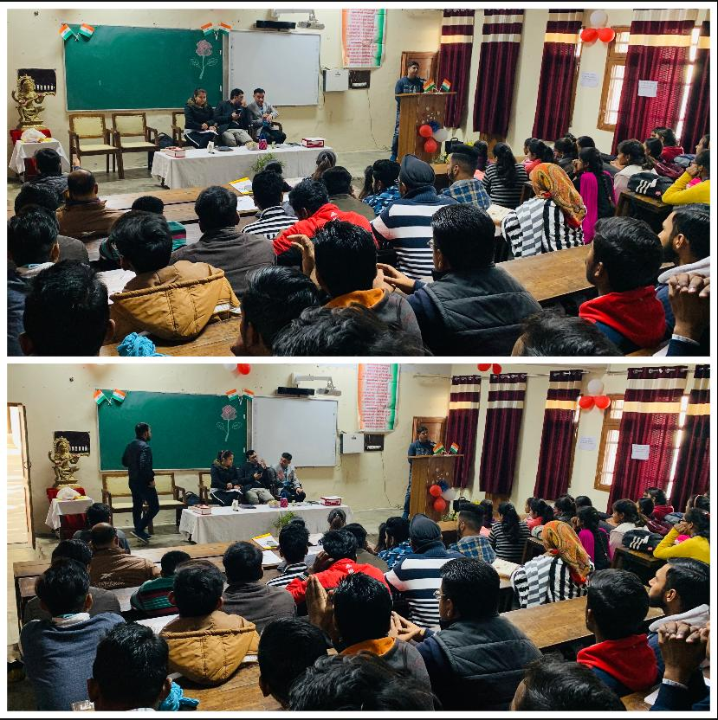

REGISTERED STARTUP TEAMS

S NO. | NAME OF STARTUP | NAME OF FOUNDER | DESCRIPTION | SECTOR
1 | Shop Towns | Sachin | Online Marketing Portal | Marketplace
2 | Rudraksh Event Management | Bharat | Event Planner | Service
3 | Radhey Krishna Dairy Farm | Balbinder | Dairy product and YouTube channel | Agriculture
4 | Prithvi Gardening Tech | Vasu | Plant Nursery & Terrasse Gardening Solutions | Agriculture
5 | Navu Art & Craft | Navneet | Craft | Art & Craft
6 | MN Handloom | Afsana | Manufacturing Mats from Recycled Material | Lifestyle
7 | Marketing Hub | Ravi | Doing online and offline marketing | Marketing
8 | Her Crafts | Diksha | Craft | Art & Craft
9 | Healthy Life diet clinic | Reena | Service of Diet Plans | Service
10 | Happy Hands | Dimpal | Mehandi and Nail Art Services | Service
11 | Eco Fields | Rohit | Manufacturing Organic Compost | Agriculture
12 | Digicell | Aashish | Providing Digital Marketing Solutions | Marketing
13 | Craft Hub | Dimpi | Craft | Art & Craft
14 | Build it Better | Himanshi | Providing Service of making maps of Buildings | Art & Craft
15 | Book4u | Vinay | Providing Service of Academic Books | Marketplace
16 | Book World | Prerna | Providing Online Portal of Books | Marketplace
17 | Arty Crafty | Deeksha | Craft | Art & Craft
18 | AK Crafts | Anjali | Craft | Art & Craft
19 | Alphabetz | Anita | Play School | E-learning
20 | Anupam Pickles | Ankush | Providing Different Pickles | FMCG
21 | Perception 2.0 | Vandana | Service of Graphic & Logo Desiging | Designing
22 | Yoga Planet | Aayushi | Customized Yoga Classes | Service
23 | Women Empire | Neha | Online Group for Lifestyle | Lifestyle
24 | VS Jobs | Rohit | Providing Jobs | Service
25 | Tour Takers | Kajal | Tour Guide | Service
26 | The Learning Point | Sonia | Tutor | E-learning
27 | Super power Securities | Sumit | Providing Security Services | Service
28 | Around Services | Sahil | Providing Online Portal for Services | Service
29 | AWS Gallery | Saloni | Sale and Training of Craft items | Craft
30 | Form Markit | Nihal | Form filling | Service

REVENUE OF REGISTERED STARTUP TEAMS
S NO. | NAME OF STARTUP | FOUNDER | DESCRIPTION | SECTOR | REVENUE
1 | Shop Towns | Sachin | Online Marketing Portal | Marketplace | 5,000
2 | Rudraksh Event Management | Bharat | Event Planner | Service | 7,500
3 | Radhey Krishna Dairy Farm | Balbinder | Dairy product and YouTube channel | Agriculture | 10,000
4 | Prithvi Gardening Tech | Vasu | Plant Nursery & Terrasse Gardening Solutions | Agriculture | 25,000
5 | Navu Art & Craft | Navneet | Craft | Art & Craft | 5,000
6 | MN Handloom | Afsana | Manufacturing Mats from Recycled Material | Lifestyle | 15,000
7 | Her Crafts | Diksha | Craft | Art & Craft | 5,000
8 | Healthy Life diet clinic | Reena | Service of Diet Plans | Service | 20,000
9 | Happy Hands | Dimpal | Mehandi and Nail Art Services | Service | 18,000
10 | Digicell | Aashish | Providing Digital Marketing Solutions | Marketing | 20,000
11 | Craft Hub | Dimpi | Craft | Art & Craft | 2,700
12 | Build it Better | Himanshi | Providing Service of making maps of Buildings | Art & Craft | 3,500
13 | Arty Crafty | Deeksha | Craft | Art & Craft | 4,000
14 | AK Crafts | Anjali | Craft | Art & Craft | 2,000
15 | Anupam Pickles | Ankush | Providing Different Pickles | FMCG | 15,000
16 | Perception 2.0 | Vandana | Service of Graphic & Logo Designing | Designing | 1,500
17 | VS Jobs | Rohit | Providing Jobs | Service | 20,000
18 | The Learning Point | Sonia | Tutor | E-learning | 12,000
19 | Super power Securities | Sumit | Providing Security Services | Service | 20,000

SECTORIAL DIVERSIFICATION

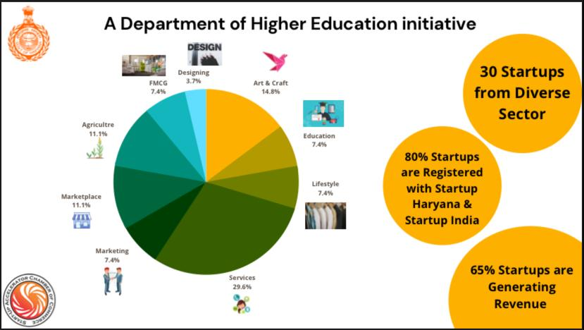

Mr Sunant Grover
Centre Head
Contact- 9896045678
Email-sunant@saccindia.org

THANK YOU

