Activity of the Biotechnology Department for session 2021-22

Sr. No | Date | Activity Name | Teacher | No. of Student
Activity No.1 | 25.11.2021 | Essay Writing Competition | All | 20
Activity No. 2 | 20.12.21 | Poster Making Competition | All | 9
Activity No.3 | 21.12.21 | Slogan Writing Competition | All | 10
Activity No. 4 | 20.04.22 | Plant Tissue Culture Laboratory Visit | 03 | 44

Activity No.1 | 25.11.2021 | Essay Writing Competition

An essay writing competition was held in Department of Biotechnology under the guidance of Faculty member of department. Venue for essay writing competition was Department of Biotechnology. A total of 20 participants from B.Sc. Medical and Biotechnology participated in essay writing competition. These were judged by Dr. Vijay Kumar and Dr. Vikas Sikerwal from Zoology and Dr. Vikas from Biotechnology Department.
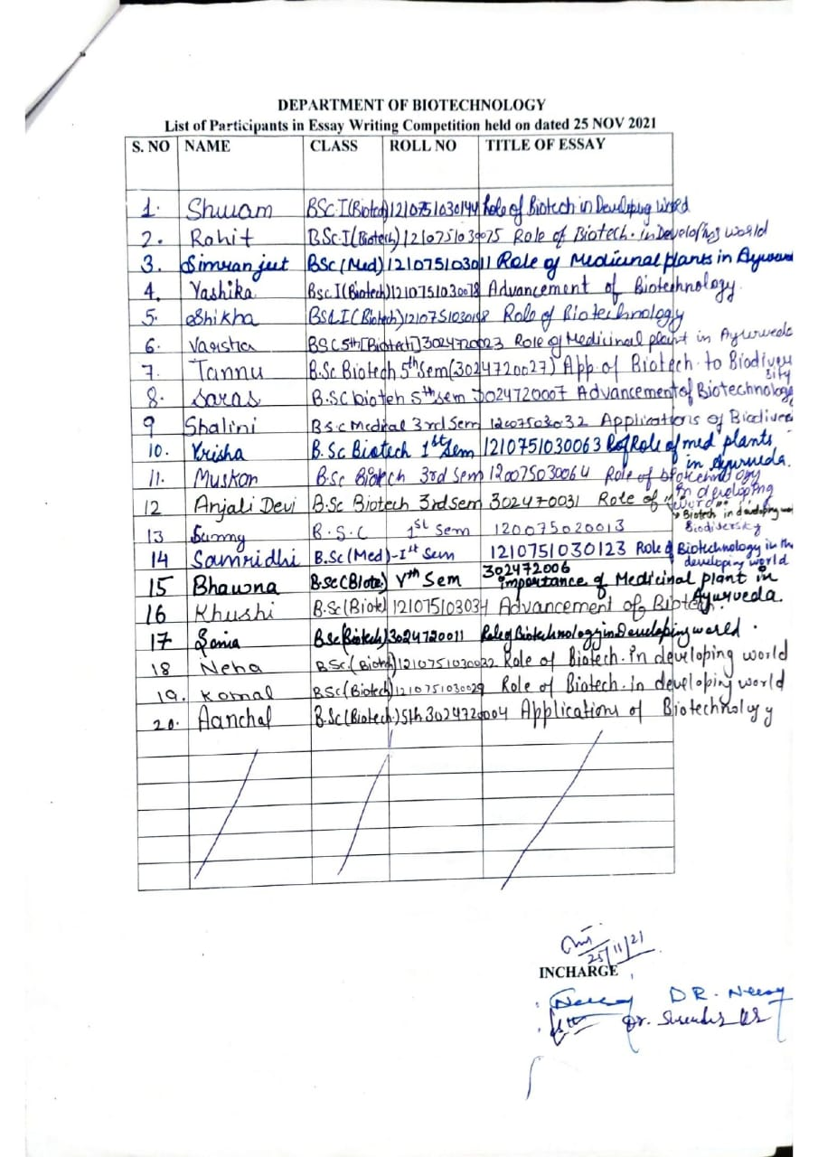
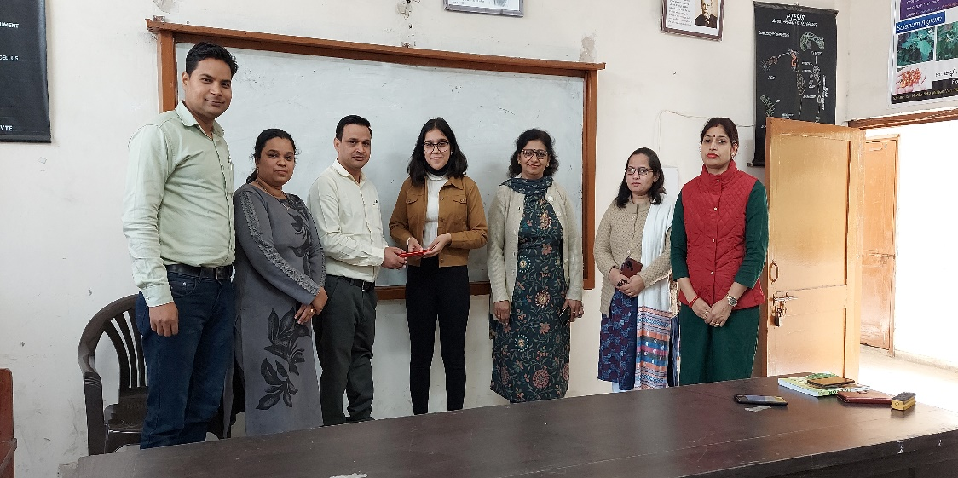

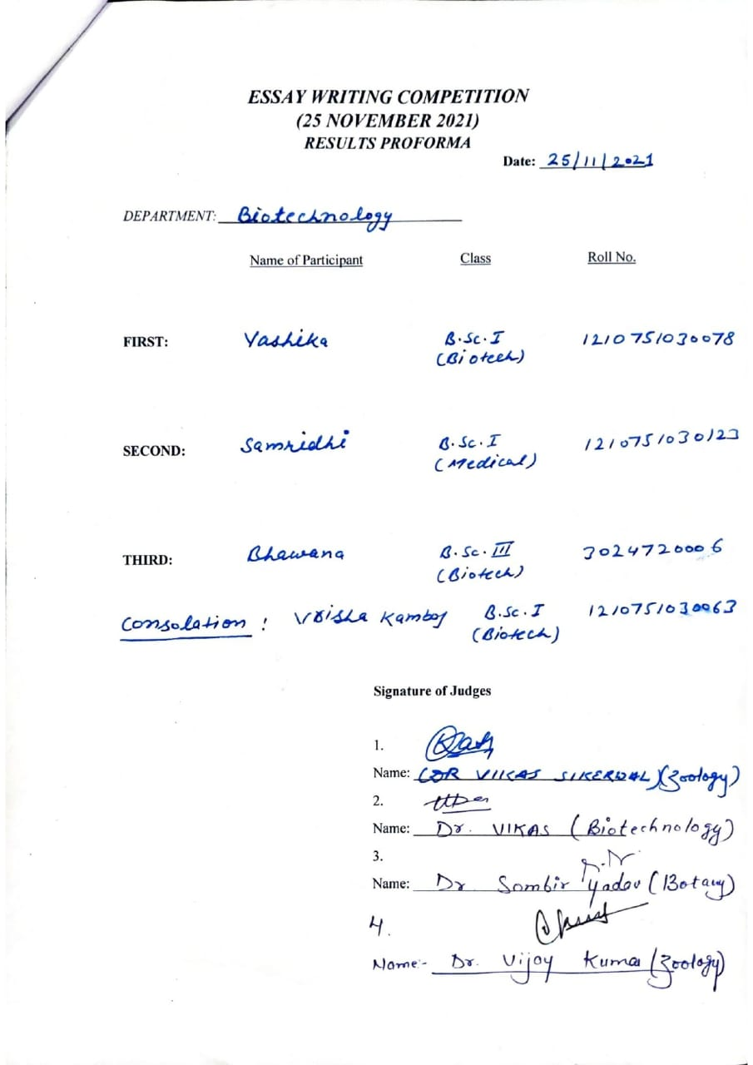

Activity No.2 | 20.12.2021 | Poster Making Competition
Department of Biotechnology was organized poster making completion on 20.12.21.The topic for this competition are following
- OMICRON
- COVID 19
- RDT
- VACCINE
Total 9 students participated in this event. These were judged by Ms. Suvidha and Dr. Vikas Sikerwal from Zoology Department.

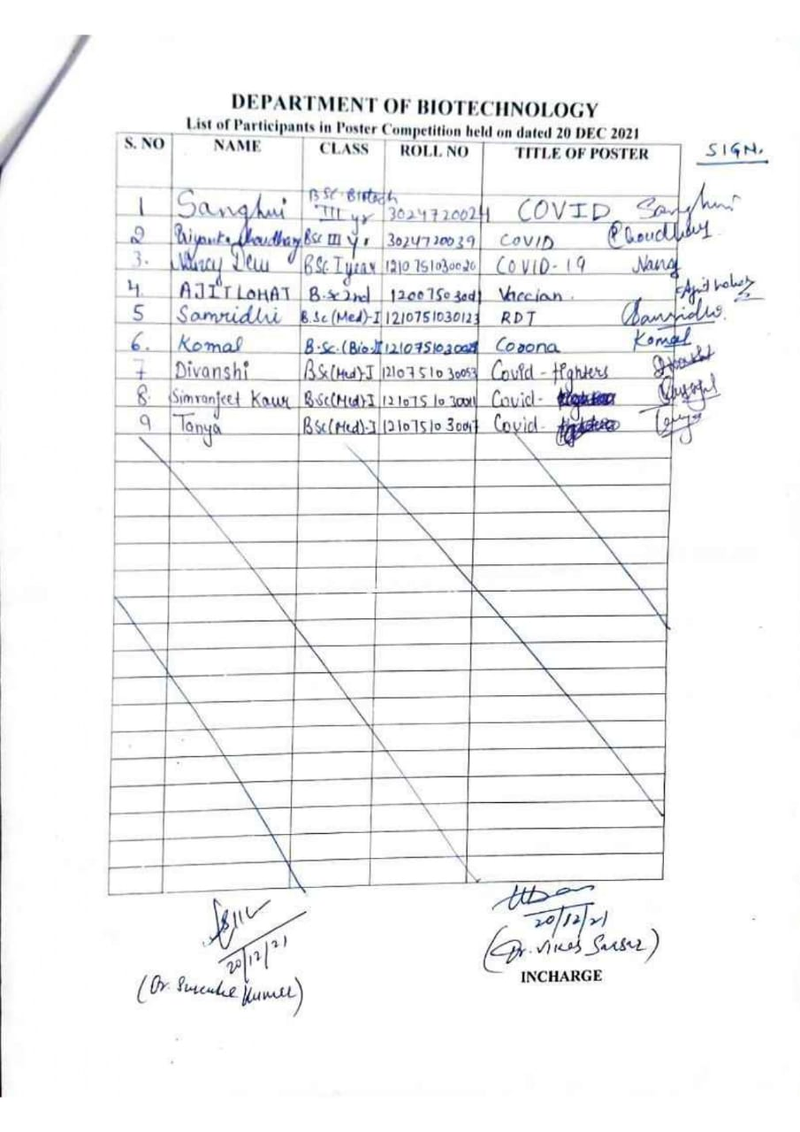
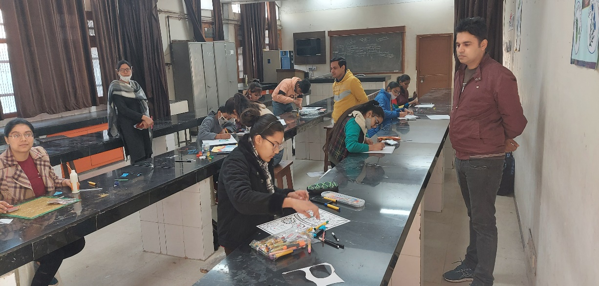
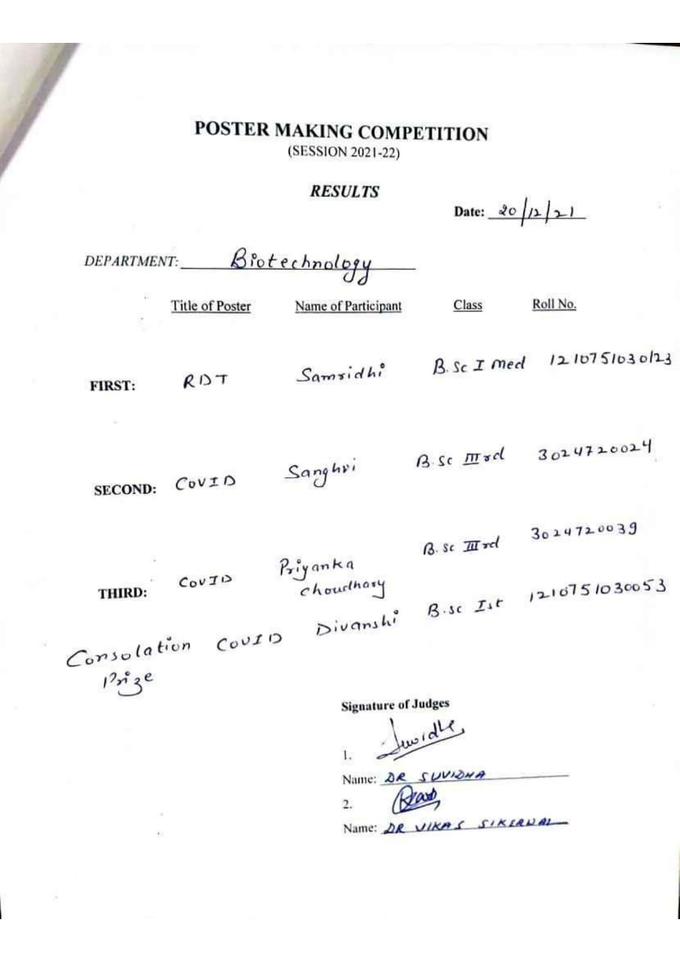

Activity No.3 | 21.12.2021 | Slogan writing Competition

A slogan writing competition was held in Department of Biotechnology under the guidance of Faculty member of department. A total of 10 participants from B.Sc. Medical and Biotechnology participated in slogan writing competition. These were judged by Dr. Ranjeet Singh and Dr. Richa Gupta from Botany Department.

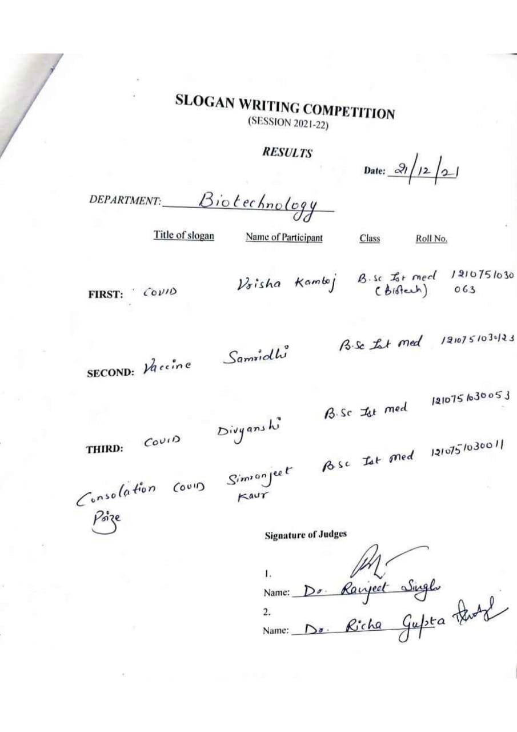

Activity No.4 | 20.4.2022 | Plant Tissue Culture Laboratory Visit

An educational trip of BSc III students was organised for Plant Tissue Culture Laboratory, under the campus of Sugar mill, Karnal. A total of 44 students were the part of this trip. The students survey the green houses and Plant Tissue Culture Laboratory. Three Teachers and one JLA from Biotechnology department accompany the students. Dr. Sarina, Production Head of PTC Laboratory and their technical staff was given information regarding culture techniques.